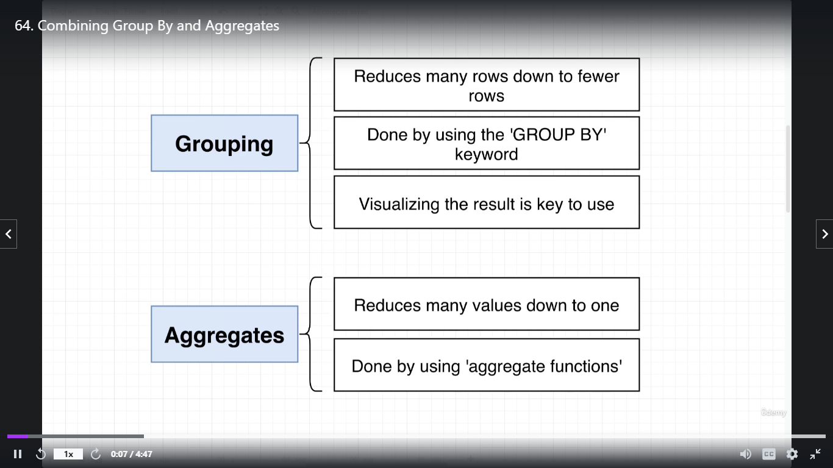

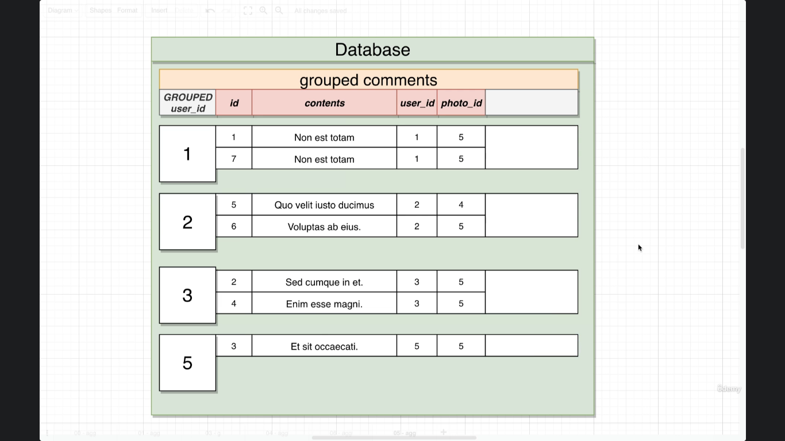

--there are many id in grouped with single unique user_id and the max ofthem selected

**select** max(id)

**from** comments

**group** **by** user_id

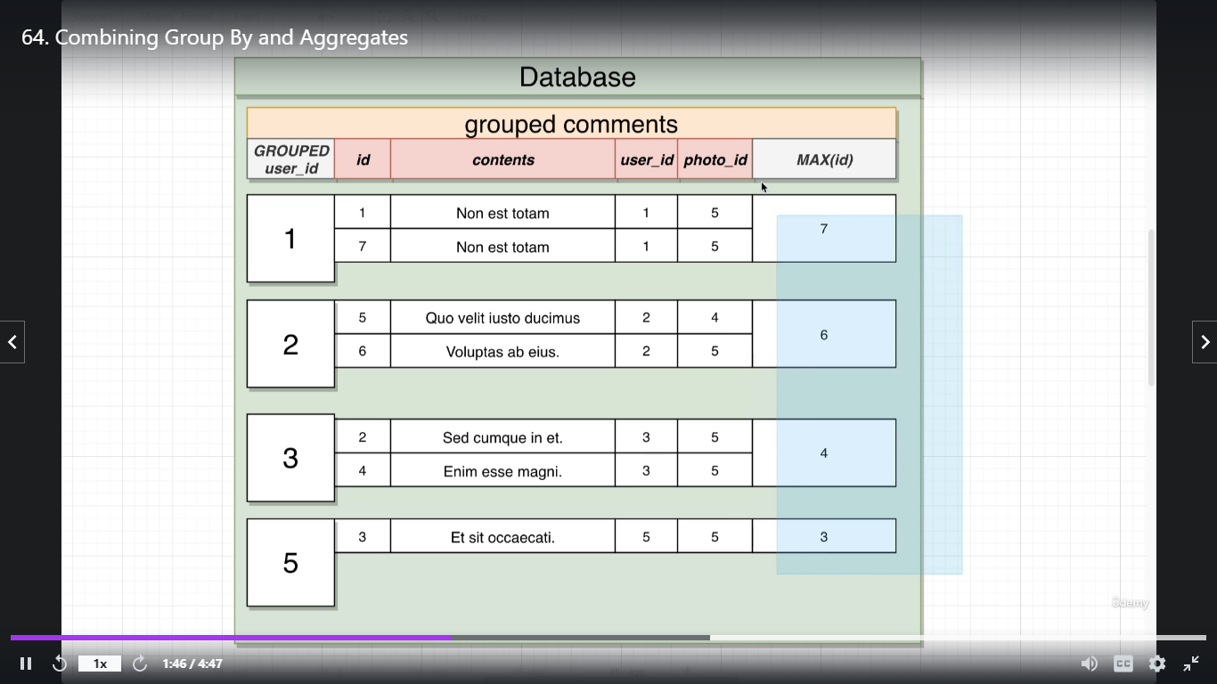

--count means how many in each uniee grouped by group value

**select** user_id, count(id)

**from** comments

**group** **by** user_id

